**Muhammad Yasin Wahidullah-SP20-BSE-059**

**RAILWAY RESERVATION SYSTEM**

**RESERVE A SEAT (USE CASE)**

**BRIEF**

This Use Case will begin when the passenger wants to reserve a Seat. He will need to fill the reservation form to enter his current city and destination city, select time slot, select seat, and confirm the payment through available payment methods and print the provided ticket.

The details of the available seats, time of departure of train, and cost of ticket will be provided by the system.

**USE CASE DIAGRAM**

**FULLY DRESSED DIAGRAM**

|  |  |
| --- | --- |
| **USE CASES** | **COMMENT** |
| Use Case Name | Reserve Seat |
| Scope | Railway Reservation System |
| Level | User Goal |
| Primary Actor | Passenger |
| Stockholders and Interests | Passenger: wants to reserve a seat in a train  Admin: wants the detail of the passenger |
| Preconditions | The user must be registered and logged in |
| Success Guarantee | The seat of the user will be successfully reserved |
| Main Success Scenario | The user will provide details about his seat, location, pay the bill, and then his seat will be successfully reserved |
| Extensions | If the details are not correct the reservation will be failed |
| Special Requirements | Reliability, Maintainability, and Usability |

**Domain Model**

**System Sequential Diagram**

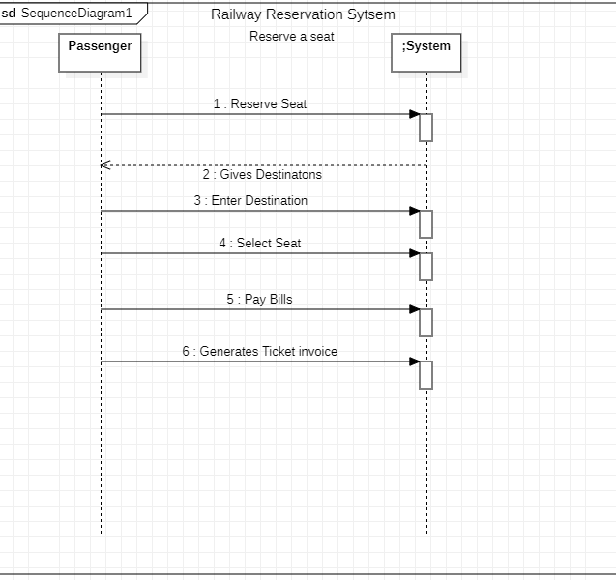

**Operation Contracts**

**OPERATION –** Select Seat

**CROSS REFERENCE –** Reserve a Seat

**PRECONDITION –** the passenger must be registered and logged in.

**POSTCONDITION –** the seat has been reserved by the passenger